BREAKFAST

I HAVE BREAKFAST FROM 7-8 O CLOCK. FOR BRAKFAST I HAVE A SANDWICH AND ORANGE JUICE OR CEREAL WITH MILK.
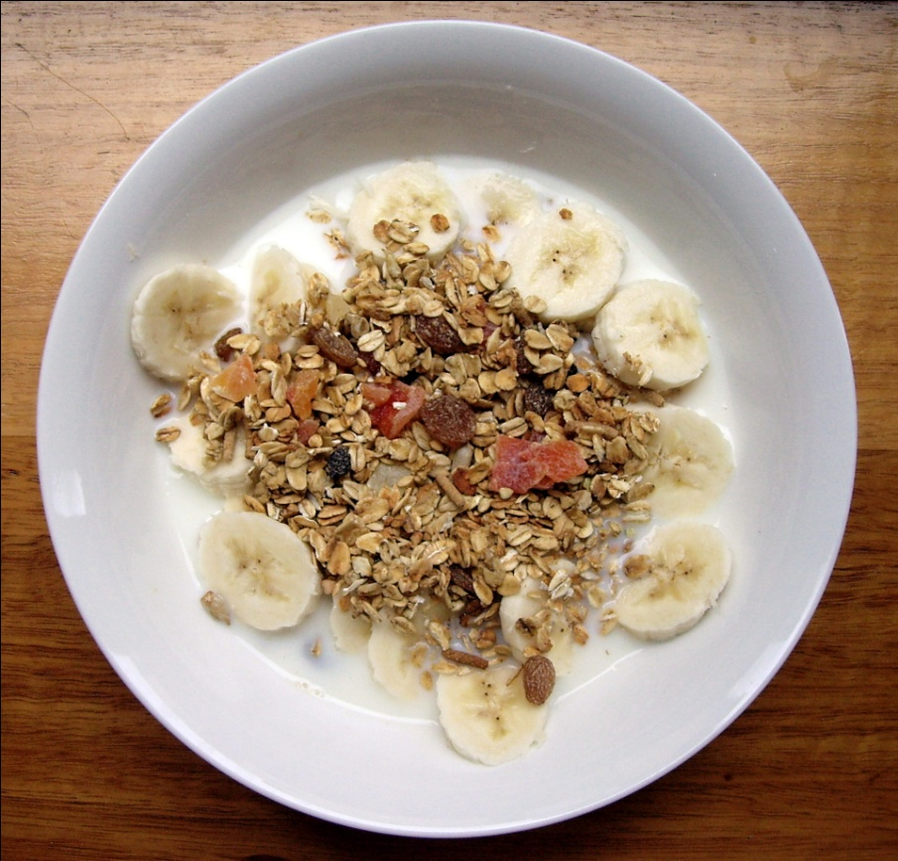

LUNCH

I HAVE LUNCH AT 1 O' CLOCK. FOR LUNCH I HAVE ROAST BEEF WITH POTATOES. I ALSO HAVE SALAD WITH TOMATOES,LETTUCE AND CUCUMBERS.
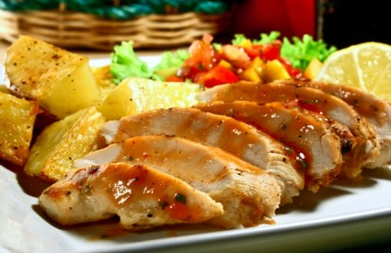

DINNER

FOR DINNER I SOMETIMES HAVE PANCAKES WITH NUTELLA OR MARMALADE. MY DINNER IS USALLY BETWEEN 7-8 O' CLOCK IN THE EVENING.
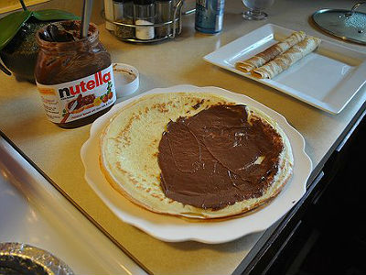
Jelena Maleš, 5.d

